|  |
| --- |
| **[demo intro to Caerus geo]** |
| American Red Cross International Services  http://americanredcross.github.io |

Table of Contents

Introduction 1

Overview 1

What is CaerusGeo? 1

Using CaerusGeo 1

Create an Account 1

Name Your Survey 2

Choose Survey Type 2

Build Your Survey Schema 2

Locate Your Survey Area 3

Review Your Survey 4

# Introduction

## Overview

The Geographic Information Systems (GIS) office at American Red Cross is deeply involved in international disaster response and disaster preparedness programs throughout the world. Accurate and quality surveys to establish baseline and monitoring data allows Red Cross chapters around the world better implement programs. GIS specialists are able to use collected data for map production and advanced analysis. It is likely that volunteers and field staff will be increasingly requested to participate in geospatial data collection. Those people responsible for the data collection should also be able to use it directly instead of having to make all requests through GIS specialists.

This guide provides a simple demonstration of CaerusGeo. More information and resources can be found at [http://americanredcross.github.io](http://americanredcross.github.io/).

## What is CaerusGeo?

CaerusGeo (<http://caerusgeo.com>) drastically simplifies GIS data collection for Red Cross projects. Volunteers and staff can create GIS data with nothing more than pen and paper. Users draw important features on paper and note additional attributes on an accompanying spreadsheet; when Red Cross staff later enter data through the simple web interface, it's automatically transformed into usable digital data. The CaerusGeo website provides data visualization but importantly also facilitates data export.

# Using CaerusGeo

## Create an Account

* Open up your web browser and go to <http://www.caerusgeo.com>.
* If this is your first time using CaerusGeo you will need to create an account.
  + Click ‘Get started’ G:\Information Management\Maps\Documents, Forms, and Templates\Guides\Caerus Geo\Caerus Geo Demo Intro\Demo Intro Images\getStarted.png or ‘Sign-up’ G:\Information Management\Maps\Documents, Forms, and Templates\Guides\Caerus Geo\Caerus Geo Demo Intro\Demo Intro Images\signUp.png at the top-right of the screen.
  + You will need to type in your name, email, and a password. Also, set your time zone.
  + Click ‘Create Profile’ and then check your email for a message with a subject line of ‘Confirmation instructions’ from admin@caerusgeo.com. Click the ‘Confirm my account’ link to complete the creation of your account and login.

## Name Your Survey

* After logging in at <http://www.caerusgeo.com> click **New Survey** G:\Information Management\Maps\Documents, Forms, and Templates\Guides\Caerus Geo\Caerus Geo Demo Intro\Demo Intro Images\newSurvey.png at the top of the page.
* Our **Survey Title** will be “Households with Children under 5 in Example Neighborhood” so that the purpose of the survey is known. We are considering a childhood nutrition and immunization education campaign and want to know how many beneficiaries will be targeted.
* Type the title into the input box and click **Next**.

## Choose Survey Type

* Each household will be a specific location. We will mark each house on our map with a point. So select **Points** and then click **Next**.

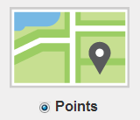

## Build Your Survey Schema

* “Build Your Survey Schema” means create your survey questions.
* As the identifier for each household we will record the household head.
  + For the **Field Heading** in box 1 type “Name of Household Head.”
  + The answer will be a different name for each household so for **Field Type** choose **Text**.
* The purpose of the survey is to locate households with young children but we also would like to know how many young children there are in each household.
  + Click **Add Another Question** to create box 2 with question 2.
  + For the **Field Heading** in box 2 type “Number of Children Under 5 Years Old.”
  + The answer will be a number so for **Field Type** choose **Number**.

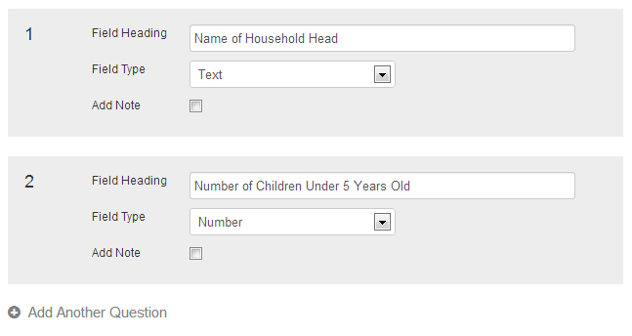

* Click **Next**.

## Locate Your Survey Area

* Our project partner will be students from Kathmandu University and they will be working in the neighborhood adjacent their school. Click in the search box at the top left corner of the map where is says **Search by Address, City, Country**, type “Kathmandu University,” and press your enter key.
* Notice that the map still shows a very large area. The scale bar in the lower left corner will show “3 km” and the length of the bar will be equal to 3 kilometers.

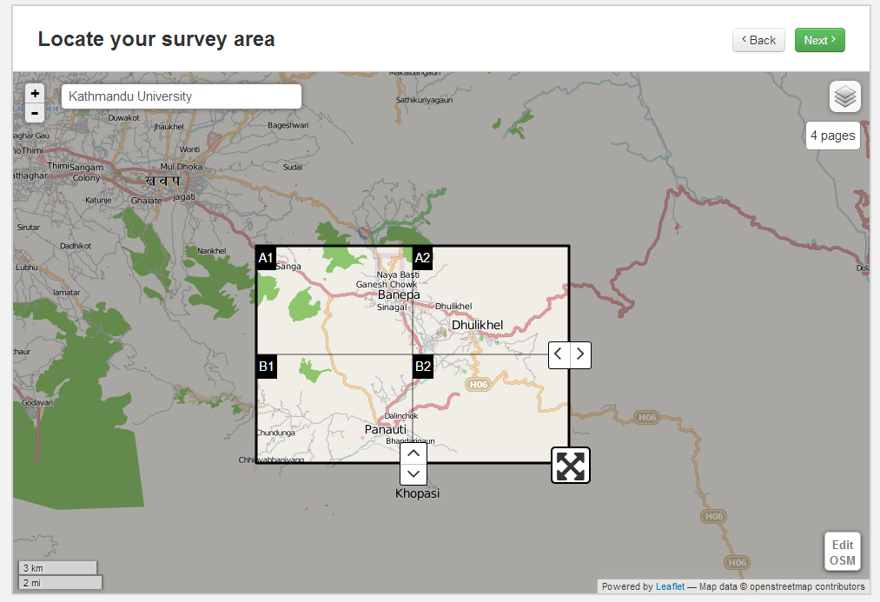

* Click the + button in the top left corner of the map several times until you can see the university. The scale bar should show “200 m” after you have zoomed in.

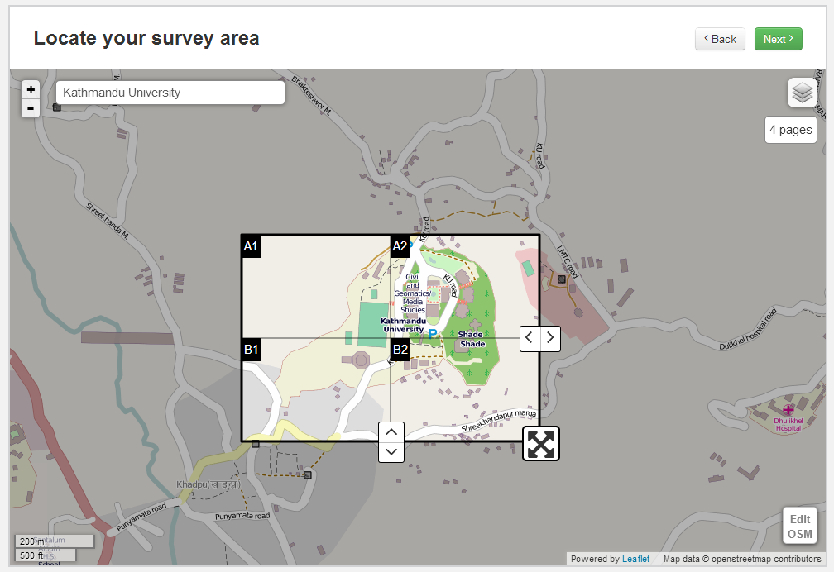

* Left click and hold the greyed out portion of the map, then drag so that the map centers over the neighborhood just north of the university (above the university on your screen).
* The grid squares are our survey area. Use the icon in the lower right of the selector to increase the size of the selected area. Left click, hold, and drag the selector to reposition. We want to include the entire area between the edge of the university and the bust stop on the main road.

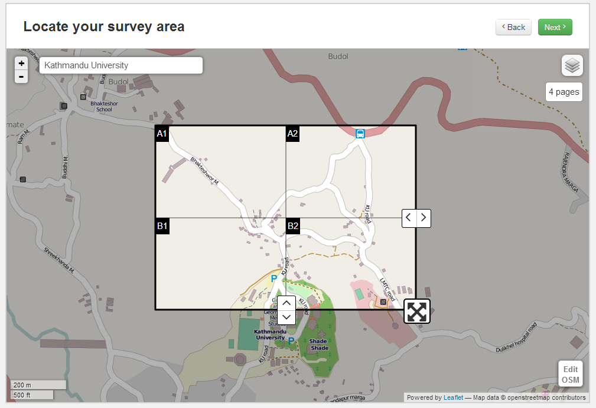

* We can change the number of grid tiles with the arrow icons at the right-center and bottom-center of the selector box. Each tile will be a survey map page. The maximum number of tiles we can use is 16. The default of 4 tiles works for our survey.
* Click **Next**.

## Review Your Survey

* Cause you mighta fucked up.

YEP, print off an atlas and worksheet and make a fake filled out survey.